***CREATE A IBM IOT WATSON IOT PLATFORM AND A DEVICE***

|  |  |
| --- | --- |
| ***Team ID*** | ***PNT2022TMID37002*** |
| ***Project Name*** | ***Smart Farmer - IoT Enabled Smart Farming Application*** |

Step1: Log in your registered id

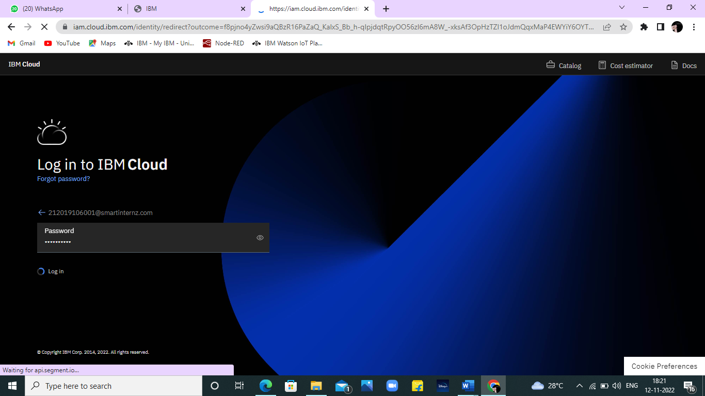

Step 2: click catalog where you find the services and internet of thing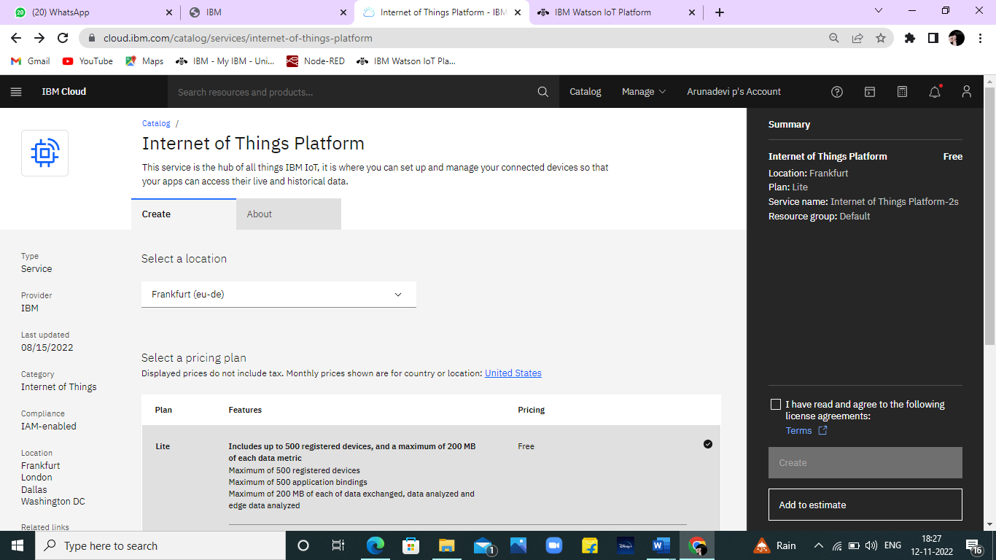

Step 3: click create and the launch tab get open, then click launch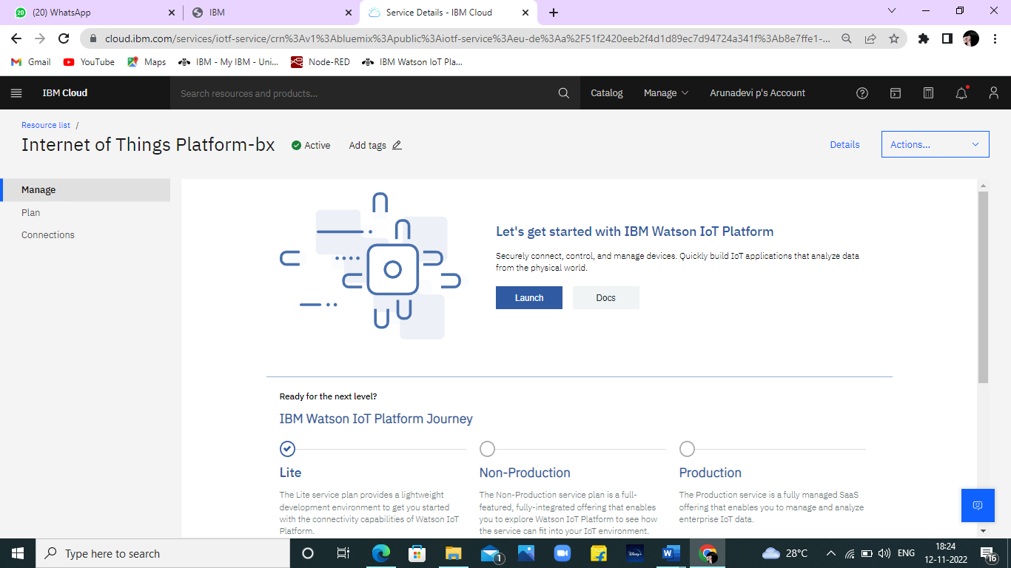

Step 4: It redirect you to IBM WATSON platform where you need to click sign in

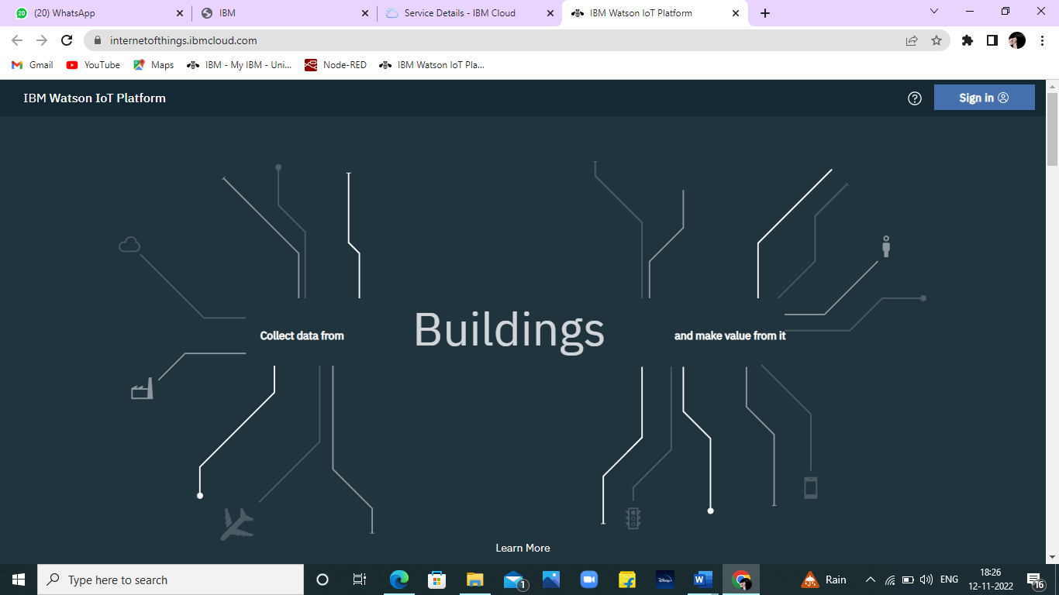

Step 6: where you find this tab which is used to add device, app, member, usage, and security can be worked

